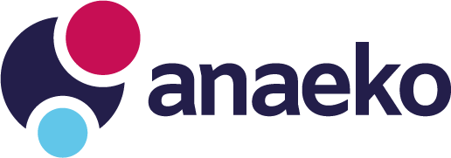

Open Data Business Model
Mini Pitch Application Form

Business Concept
Business Name | A short and unique name for your business idea
Strapline | A short marketing strapline to communicate the idea
Elevator Pitch | Describe the key concept in no more 200 words, including the market need, your innovative solution and how Open Data is leveraged

The Team
Team Name | The name of the team behind the idea. Can be an existing company or community name or a name chosen for the competition
Team Leader | Name and title of the team leader and spokesperson
Team Members | Names and titles of up to 4 other team members
Contact Details | Email address or phone number to be used to for competition alerts.  Used only for competition purposed and details will not be shared

The Business Concept
Description | Describe your idea in no more than 500 words
Open Data Sets | List Open Data that will be used by the business.  At least one data set must come from Open Data NI  Include links to data sets on https://www.opendatani.gov.uk/
Opportunity | Describe in no more than 100 words, the problem it solves, the addressable market opportunity and your proposed route to market
Revenue Stream | Describe in no more than 100 words where revenue comes from, who pays for the service and how much
Benefit | Describe in no more than 100 works the social and economic impact of your service

Email your completed application form to OpenData@Anaeko.com by 5pm on 21st July 2020
Shortlisted applications will be selected by a judging panel on 24th July 2020
Shortlisted teams will pitch their idea between 2:30 and 4:00pm on 30th July 2020

